Web Mining Digital Assignment 2

## Name: Om Ashish Mishra

## Registration Number: 16BCE0789

## Slot: F2

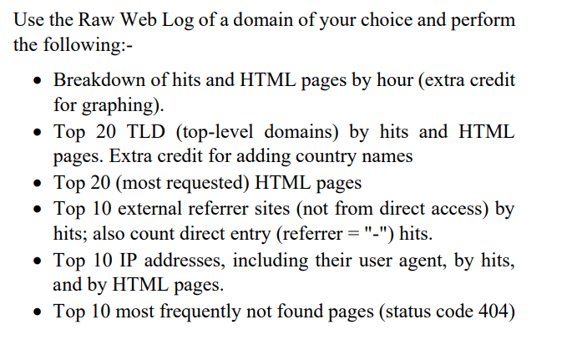

**Answer:**

**1. Raw Web Log Used:-**

HTTP/1.1 maya.cs.depaul.edu (Google Search Link)

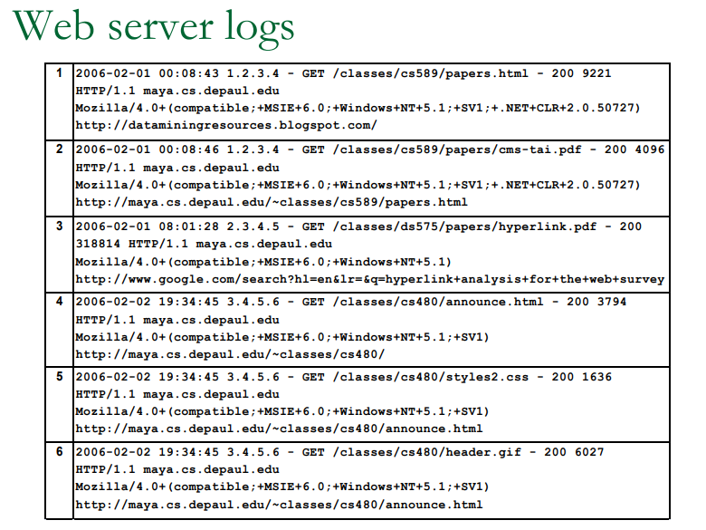

From Above Web Log

Hourly Basis:-

|  |  |
| --- | --- |
| Part 1: | Hits and HTML |
| 2006-02-01 00:08:43 | <http://dataminingresources.blogspot.com/> (26) |
| 2006-02-01 00:08:46 | <http://facweb.cs.depaul.edu/mobasher/> (11) |
| 2006-02-01 08:01:28 | hyperlink analysis for the web survey(google search) (50+) |

|  |  |
| --- | --- |
| Part 2: | Hits and HTML |
| 2006-02-02 19:34:45 | <http://facweb.cs.depaul.edu/mobasher/> (11) |
| 2006-02-02 19:34:45 | <http://facweb.cs.depaul.edu/mobasher/> (11) |
| 2006-02-02 19:34:45 | <http://facweb.cs.depaul.edu/mobasher/> (11) |

The Brackets represent the hits took place in the particular page and therefore it shows the hyperlinks and no of download links as total.

The Graph:

Part 1:

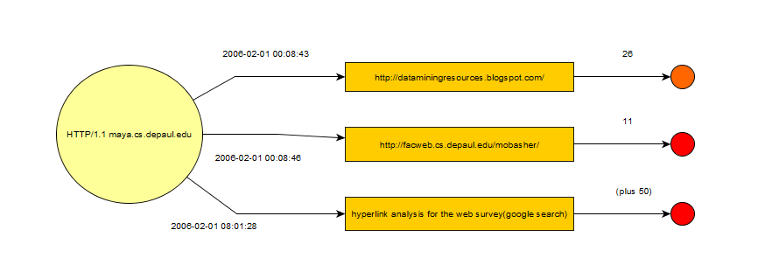

In part two the different page site is visited at the different time from 3 different people from the Raw Log.

Part 2:

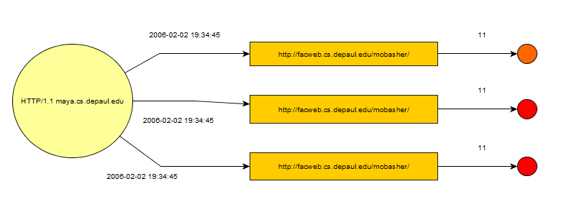

In part two the same page site is visited at the same time from 3 different people from the Raw Log.

**2. Top 20 Links available are:-**

The Links are:-

1. <https://books.google.co.in/books?isbn=3642194605> INDIA
2. [facweb.cs.depaul.edu/mobasher/classes/ect584/Lectures/12-web-usage-mining.pdf](http://facweb.cs.depaul.edu/mobasher/classes/ect584/Lectures/12-web-usage-mining.pdf) INDIA
3. [www.dais.unive.it/~dm/New_Slides/10_WUM.pdf](http://www.dais.unive.it/~dm/New_Slides/10_WUM.pdf) USA
4. [web.iiit.ac.in/~bharath_kumar/.../data_1/Research%20Web%20Mining_id_url.txt](http://web.iiit.ac.in/~bharath_kumar/LEADERPAGE/data_1/Research%20Web%20Mining_id_url.txt) INDIA
5. <https://www.cs.helsinki.fi/u/langohr/graphmining/slides/chp4a.pdf> ISREAL
6. [www.jatit.org/volumes/Vol34No2/11Vol34No2.pdf](http://www.jatit.org/volumes/Vol34No2/11Vol34No2.pdf) INDIA
7. [mail.im.tku.edu.tw/~myday/teaching/1011/WM/1011WM12_Web_Mining.pdf](http://mail.im.tku.edu.tw/~myday/teaching/1011/WM/1011WM12_Web_Mining.pdf) CHINA
8. [www.ajms.co.in/sites/ajms2015/index.php/ajms/article/viewFile/515/441](http://www.ajms.co.in/sites/ajms2015/index.php/ajms/article/viewFile/515/441) INDIA
9. [https://www.coursehero.com › Illinois Institute Of Technology › ITMD › ITMD 525](https://www.coursehero.com/file/peta3e/456-GET-classescs480styles2css-200-1636-HTTP11-mayacsdepauledu/) ILLINOIS
10. <https://slideplayer.com/slide/6219382/> UK
11. [citeseerx.ist.psu.edu/viewdoc/download?doi=10.1.1.304.5891&rep=rep1...pdf](http://citeseerx.ist.psu.edu/viewdoc/download?doi=10.1.1.304.5891&rep=rep1&type=pdf) INDIA
12. [shodhganga.inflibnet.ac.in/bitstream/10603/44185/16/16_references.pdf](http://shodhganga.inflibnet.ac.in/bitstream/10603/44185/16/16_references.pdf) INDIA
13. [https://www.slideshare.net/.../web-usage-mining-temas-avanzados](https://www.slideshare.net/jazcurra/web-usage-mining-temas-avanzados) ARGENTINA
14. [https://www.researchgate.net/.../259575782_Fuzzy_Co-Clustering_of_Web_Documents](https://www.researchgate.net/publication/259575782_Fuzzy_Co-Clustering_of_Web_Documents_and_its_Problems) INDIA
15. [meri.edu.in/meri/wp-content/uploads/2017/01/Mooc-on-Weka.pdf](http://meri.edu.in/meri/wp-content/uploads/2017/01/Mooc-on-Weka.pdf) INDIA
16. [www.worldcomp-proceedings.com/proc/proc2015/DMIN15.../DMIN15_Papers.pdf](http://www.worldcomp-proceedings.com/proc/proc2015/DMIN15_Final_Edition/DMIN15_Papers.pdf) INDIA
17. [kb.psu.ac.th/psukb/bitstream/2553/2100/3/281913_bibli.pdf](http://kb.psu.ac.th/psukb/bitstream/2553/2100/3/281913_bibli.pdf) UK
18. [iopscience.iop.org/article/10.1088/1757-899X/166/1/012031/pdf](http://iopscience.iop.org/article/10.1088/1757-899X/166/1/012031/pdf) INDIA
19. [www.cs.joensuu.fi/pages/whamalai/sciwri/sciwri.pdf](http://www.cs.joensuu.fi/pages/whamalai/sciwri/sciwri.pdf) FINLAND
20. [nlp.uned.es/WebMining/Tema1.Introducción/ FRANCE](http://nlp.uned.es/WebMining/Tema1.Introducci%F3n/)

**3. Top 20 HTML available are:-**

**Same as above.** The pages are arranged according to SEO(Search Engine Optimization) and are made as per click bits by users and Page Ranking too. Therefore they above links represents the most visited and most requested HTML links available to get the data most accurately close to the term given or **Raw Website Log** given by the user.

**4. Top 10 external referral sites:-**

1. <https://scholar.google.co.in/scholar?rlz=1C1CHZL_enIN763IN763&biw=1242&bih=597&um=1&ie=UTF-8&lr&cites=17210335240485935579> (7)
2. <https://www.researchgate.net/profile/Myra_Spiliopoulou/publication/265142499_Ein_Ausblick_zum_Forschungsgebiet_Web_Usage_Mining/links/5582e4f208ae12bde6e6380d/Ein-Ausblick-zum-Forschungsgebiet-Web-Usage-Mining.pdf> (6)
3. <http://komputika.tk.unikom.ac.id/_s/data/jurnal/v2no2/1.aprianti-memanfaatkan-big-data-untuk-mendeteksi-emosi.pdf/pdf/1.aprianti-memanfaatkan-big-data-untuk-mendeteksi-emosi.pdf> (4)
4. <https://www.researchgate.net/profile/A_Sukhov2/publication/308847761_Analysis_of_Internet_service_user_audiences_for_network_security_problems/links/59f70f57aca272607e2bee41/Analysis-of-Internet-service-user-audiences-for-network-security-problems.pdf> (6)
5. <https://onlinelibrary.wiley.com/doi/abs/10.1002/1532-2890(2000)9999:9999%3C::AID-ASI1066%3E3.0.CO;2-Y> (5)
6. <https://pdfs.semanticscholar.org/1e0c/5c6fe81bf965b179edf2c53c2f5c34d2efdb.pdf> (5)
7. <https://hal.archives-ouvertes.fr/hal-00560096/> (4)
8. <https://dl.acm.org/citation.cfm?id=1526732> (3)
9. <http://www-sop.inria.fr/dias/Theses/phd-73.pdf> (3)
10. <https://link.springer.com/chapter/10.1007/978-3-322-89871-5_7> (4)

The Brackets show **the number of referral** to a particular page and how the Raw Website Log is used as **the citation Link** for those pages.

**5. Top 10 IP Addresses with user agent and HITS of HTML page:-**

|  |  |  |
| --- | --- | --- |
| IP | User Agent | HITS of HTML |
| 172.217.11.14 | lga25s60-in-f14.1e100.net | 12 |
| 140.192.36.128 | facweb.cs.depaul.edu | 24 |
| 18.34.67.123 | dais.unive.it | 13 |
| 14.139.82.8 | web.iiit.ac.in | 27 |
| 66.219.22.160 | jatit.org | 34 |
| 163.13.201.222 | mail.im.tku.edu.tw | 12 |
| 104.16.148.224 | coursehero.com | 17 |
| 182.50.130.87 | ajms.co.in | 25 |
| 14.139.116.20 | shodhganga.inflibnet.ac.in | 33 |
| 108.174.11.74 | slideshare.net | 29 |

The link used for the IP address and User Agent:-

<https://ipinfo.info/html/ip_checker.php>

**6. Top 10 most frequently not found pages (404):-**

<https://flippingbook.com/404>

<https://www.behance.net/gallery/46128269/404-Page-Stranger-Things>

urlOfMy404errorPage.html

<https://weeblr.com/joomla-seo-analytics-security/404-page-keep-those-lost-visitors>

<https://www.daar-om.nl/404-paginas-en-moet-ermee/attachment/404/>

<https://aradbranding.ir/%D8%B1%D9%81%D8%B9-%D8%A7%DB%8C%D8%B1%D8%A7%D8%AF-%D9%88-%D8%A7%D8%B4%D8%AA%D8%A8%D8%A7%D9%87%D8%A7%D8%AA-%D8%B3%D8%A7%DB%8C%D8%AA-%D8%A8%D8%B1%D9%86%D8%AF%DB%8C%D9%86%DA%AF/>

<https://churchthemes.com/page-didnt-load-google-maps-correctly/>

<https://builtvisible.com/optimizing-your-404-page/>

<https://jp.123rf.com/photo_55885004_%E3%81%8A%E3%81%A3%E3%81%A8%E5%A3%8A%E3%82%8C%E3%81%9F%E9%89%9B%E7%AD%86-404-%E3%82%A8%E3%83%A9%E3%83%BC-%E3%83%9A%E3%83%BC%E3%82%B8%E3%80%81%E3%83%99%E3%82%AF%E3%83%88%E3%83%AB-%E3%83%86%E3%83%B3%E3%83%97%E3%83%AC%E3%83%BC%E3%83%88.html>

<https://kateko.bg/bg/4_404/>